**MATEMATIIKKA**

Adnan Naseer

[T8naad00@students.oamk.fi](mailto:T8naad00@students.oamk.fi)

Oulu University of Applied Sciences

contents

1 Introduction 3

2 THE WORK ENVIRONMENT 3

3 Definition 3

3.1 Number System Conversion 4

3.2 Number System Table 4

3.3 Combinatorics 4

3.4 Truth Table 5

4 Implementation 5

5 Testing 6

6 POSSIBILITIES OF FURTHER DEVELOPMENT 6

7 User Interface 7

8 CONCLUSION 10

references 10

# 

# 1: Introduction

**Introduction :**

This is the final project for Web User Interface Design and Usability. This is web-based app in which you can perform different mathematical functions.

**2: THE WORK ENVIRONMENT**

This is done by using Sublime Text (A sophisticated text editor for code). Also, the languages are HTML, JavaScript with the help of bootstrap (for CSS work). Front end is created with the help of bootstrap.

**3: Definition**

**Definition**

With this web app, you can convert number from one numeric system to another and find number system table. You can generate Combination and Permutation, Truth table of up to four value and can generate random number within or up to given range. It can be use on any kind of operating system. It will give all the results accurately.

**3.1 Number System Conversion:**

It is the first thing you will find on the front page of this web-based app. It will convert given numbers from one numeric system to another. For Example: first will be the conversion of Decimal Number in to the Binary, Hexadecimal and Octal Numbers and so on…

**3.2 Number System Table:**

It is the second thing you will find on the front page of this web-based app. It shows the First 50 Decimal numbers in to the binary, octal and hexadecimal automatically.

**3.3 Combinatorics:**

It is the third thing you will find on the front page of this web-based app. It will show the possible combinations and the permutations of the given numbers. If we select combinations, then it will just show the possible combinations of the given numbers vice versa.

**3.4 Truth Table:**

It is the forth thing you will find on the front page of this web-based app. In this part you will see the truth tables for basic operations (AND, OR, NOT).

**4: IMPLEMENTATIONS**

I have used HTML with the help of bootstrap (styling). HTML basically, is hypertext markup language which is use for the front end. All the logics and function I have performed in the JavaScript and then used by HTML.

In head tag I have include all the libraries from the bootstrap and JavaScript. Mata tag is commonly used in all HTML pages. Almost head tag is used commonly in all HTML files.

For the Number System Table and Conversion part I have used one JavaScript file because all the logics of these parts have been handled in one JS file named as numberConversiond.js.

All the logics for combinations and permutations are handled in a JS file named as combinatorics.js and then used in html file by using tags in which functions can be get by its ID from JS file.

For the truth table part, all the logics are handled in the file which is truthtable.js and then used in html file by using tags in which functions are getting by its ID from JS file.

**5: Testing**

**Testing**

After developing this web-based app, I have tested it and found some bugs and some changes in truth table part. After findings some bugs and changes in truth table part, I worked on it and make it happen according to the requirement of the project.

**6: POSSIBILITIES OF FURTHER DEVELOPMENT**

One part I left with, is the last exercise for the project which is named as Random Numbers. I cannot do it right now because the deadline is very near and have to submit my project as soon as possible.

**7: User interface**

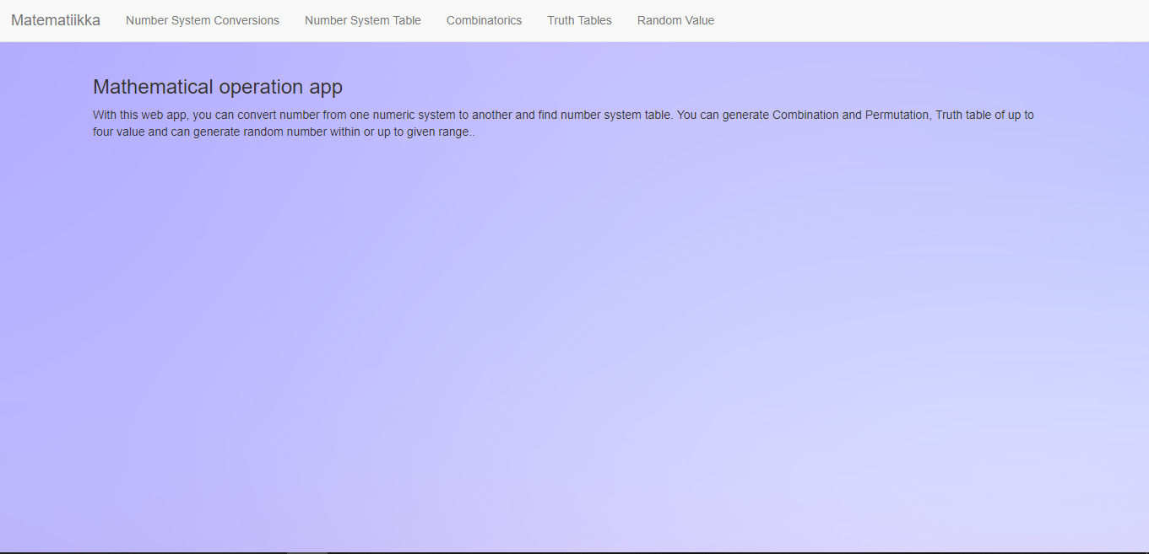

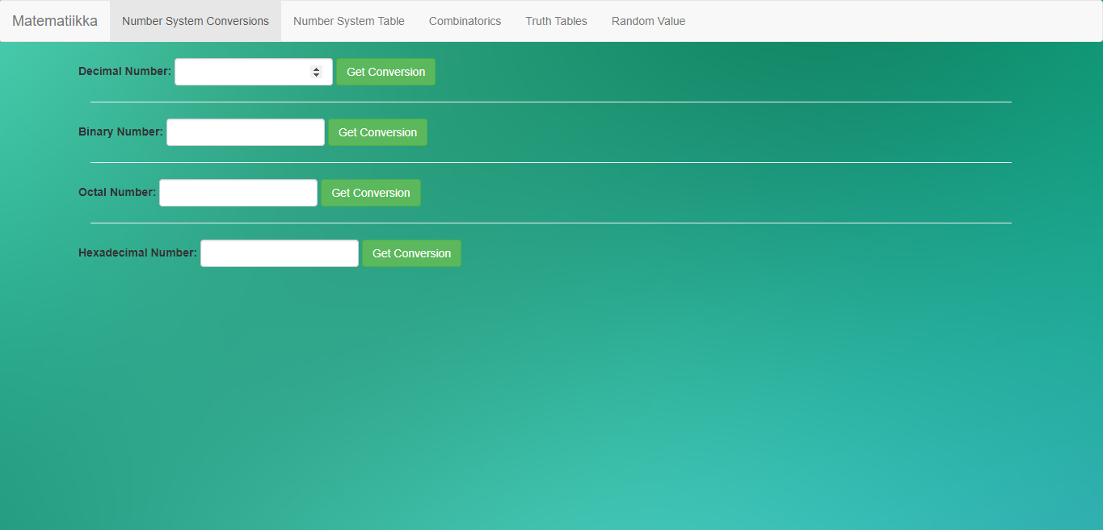

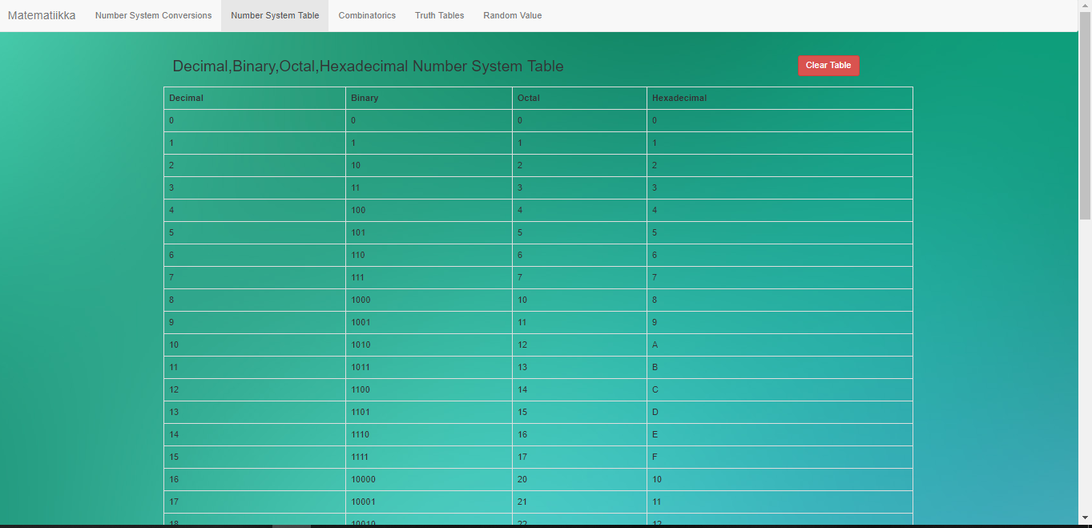

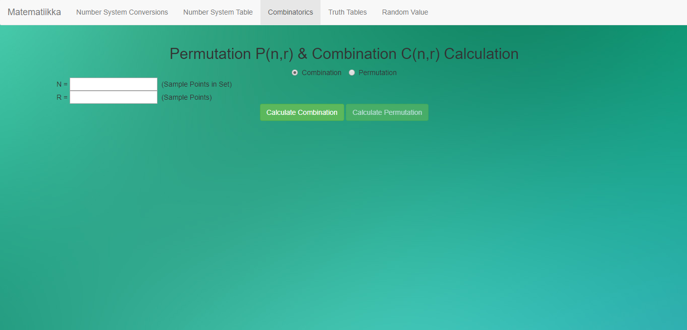

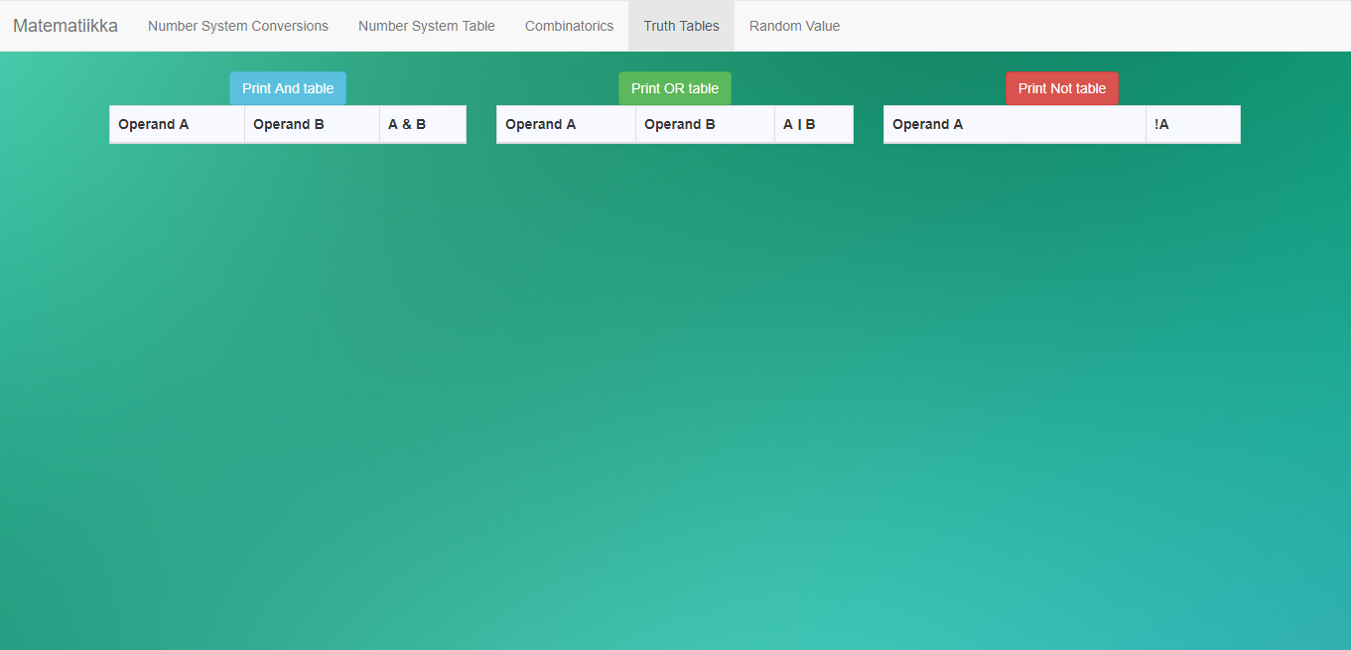

**8: conclusion**

It was very great opportunity to do this project because I learnt a lot with this project. It is very simple and good web-based app to use for the help in mathematical conversions. Every page is linked with other page and have good user interface.

**references**

1: <https://www.w3schools.com>

2: <http://getbootstrap.com>

3: <https://stackoverflow.com>

4: <https://codepen.io/awp-black-69/pen/mVOKzx>

5: <https://github.com/AdnanNaseer/Web-user-interface-project>